***+ANUDIP FOUNDATION***

**HOTEL MANAGEMENT SYSTEM**

By

Batch A Project Report on

: ANP-D0453

Student ID: AF0477163

Name: Bhagyashri Hatte

**Under the Guidance of**

Mrs. Rajshri Chandrabhan Thete

HOTEL MANAGEMENT SYSTEM

**A Hotel Management System (HMS) is a software application designed to streamline and automate hotel operations, ensuring efficiency in managing reservations, guest check-ins and check-outs, billing, housekeeping, and other essential services. This system helps hotels enhance guest experiences, optimize resource utilization, and improve overall operational effectiveness.**

**Entities:**

* Hotel
* Room
* Reservation
* Guest
* Customer
* Payment
* Service
* Departement
* Invoice

**ATTRIBUTES OF ENTITIES:**

1.Hotel

Attributes:

* Hotel ID
* Name
* Location
* Total Rooms

2. Room

Attributes:

* Room No
* Type
* Cost

3. Reservation

Attributes:

* Customer-Id
* Room No.
* Check in Date
* Check out Date

4. Guest

Attributes:

* G-ID
* G-Name
* Gender
* Phone No
* Address

5. Customer

Attributes:

* Cus Id
* Cus Name
* Cus Phone
* Cus Email

6. Payment

Attributes:

* Payment Id
* Payment Type
* Amount Paid

7. Department

Attributes:

* Home
* Manager Name

8. Invoice

Attributes:

* Invoice Id
* Amount
* Invoice date

**ENTITY RELATIONSHIP DIAGRAM - HOTEL MANAGEMENT SYSTEM**

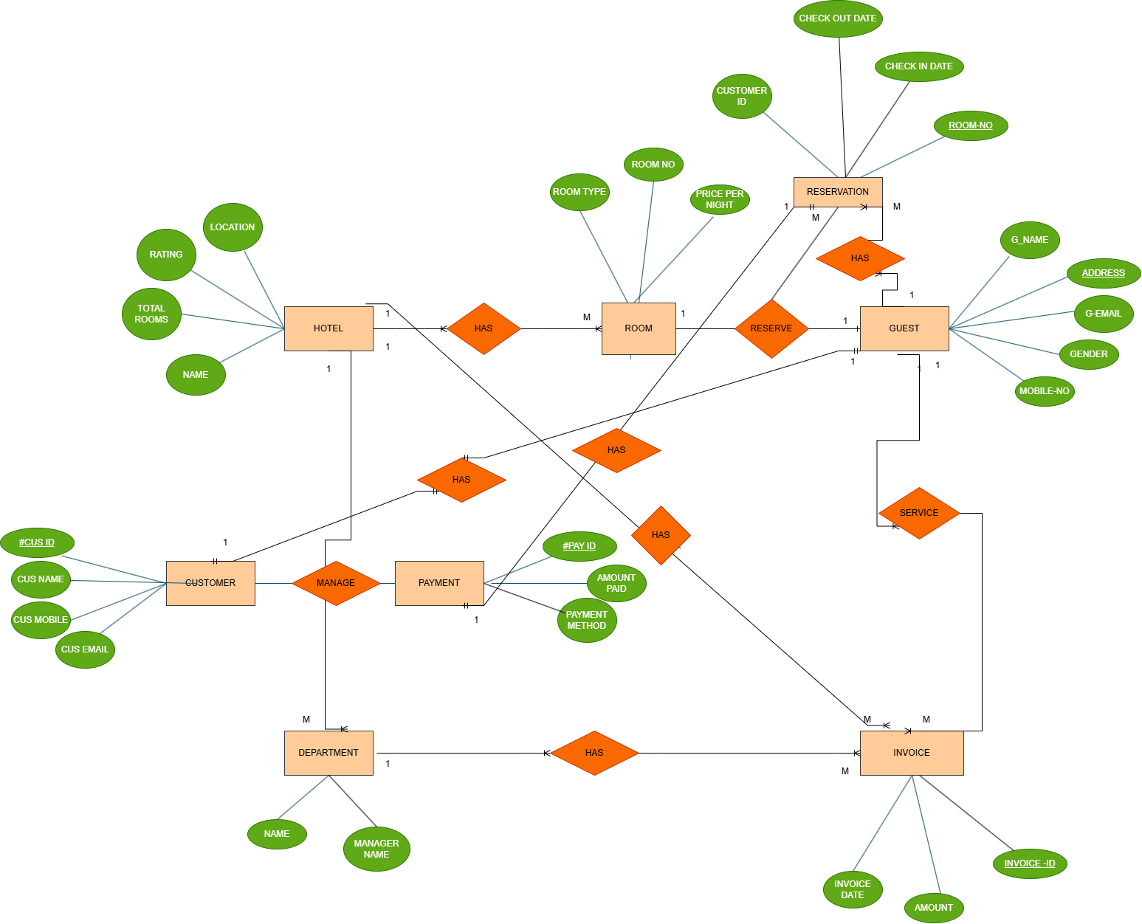

**CONCLUSION:**

**The Hotel Management System project successfully automates hotel operations like booking, check-in/out, billing, and customer management. It enhances efficiency, reduces errors, and improves service quality. The system ensures data security and real-time access, making hotel management smoother. Future improvements could include AI-driven recommendations, mobile app integration, and cloud-based solutions for better scalability and user experience. This project highlights the importance of digital transformation in the hospitality industry, paving the way for innovation and improved customer satisfaction.**

**DATABASE CREATION QUERY:**

**Query OK, 1 row affected (0.01 sec)**

**mysql>CREATE TABLE Hotel (**

**-> hotel_id INT PRIMARY KEY AUTO_INCREMENT,**

**-> name VARCHAR(100),**

**-> location VARCHAR(255),**

**-> rating FLOAT,**

**-> total_rooms INT**

**-> );**

**mysql> CREATE TABLE Room (**

**-> room_id INT PRIMARY KEY AUTO_INCREMENT,**

**-> hotel_id INT,**

**-> room_no VARCHAR(20),**

**-> category VARCHAR(50),**

**-> rent DECIMAL(10,2),**

**-> status VARCHAR(20),**

**-> FOREIGN KEY (hotel_id) REFERENCES Hotel(hotel_id) ON DELETE CASCADE**

**-> );**

**Query OK, 0 rows affected (0.02 sec)**

**mysql> CREATE TABLE Guest (**

**-> guest_id INT PRIMARY KEY AUTO_INCREMENT,**

**-> g_name VARCHAR(100),**

**-> g_age INT,**

**-> gender VARCHAR(10),**

**-> phone_no VARCHAR(20)**

**-> );**

**Query OK, 0 rows affected (0.01 sec)**

**mysql> CREATE TABLE Reservation (**

**-> reservation_id INT PRIMARY KEY AUTO_INCREMENT,**

**-> guest_id INT,**

**-> room_id INT,**

**-> r_date DATE,**

**-> FOREIGN KEY (guest_id) REFERENCES Guest(guest_id) ON DELETE CASCADE,**

**-> FOREIGN KEY (room_id) REFERENCES Room(room_id) ON DELETE CASCADE**

**-> );**

**Query OK, 0 rows affected (0.01 sec)**

**mysql> CREATE TABLE Customer (**

**-> cus_id INT PRIMARY KEY AUTO_INCREMENT,**

**-> cus_name VARCHAR(100),**

**-> cus_add VARCHAR(255),**

**-> cus_mobile VARCHAR(20),**

**-> cus_email VARCHAR(100),**

**-> cus_pass VARCHAR(100)**

**-> );**

**Query OK, 0 rows affected (0.02 sec)**

**mysql> CREATE TABLE Payment (**

**-> pay_id INT PRIMARY KEY AUTO_INCREMENT,**

**-> pay_cus_id INT,**

**-> pay_date DATE,**

**-> pay_amt DECIMAL(10,2),**

**-> pay_desc VARCHAR(255),**

**-> FOREIGN KEY (pay_cus_id) REFERENCES Customer(cus_id) ON DELETE CASCADE**

**-> );**

**Query OK, 0 rows affected (0.04 sec)**

**mysql> CREATE TABLE Department (**

**-> dept_id INT PRIMARY KEY AUTO_INCREMENT,**

**mysql> name VARCHAR(100),**

**-> d_head VARCHAR(100)**

**-> );**

**Query OK, 0 rows affected (0.04 sec)**

**mysql> CREATE TABLE Invoice (**

**-> invoice_id INT PRIMARY KEY,**

**-> dept_id INT,**

**-> payment_id INT,**

**-> service VARCHAR(100),**

**-> invoice_date DATE,**

**-> amount DECIMAL(10, 2),**

**-> FOREIGN KEY (dept_id) REFERENCES Department(dept_id),**

**-> FOREIGN KEY (payment_id) REFERENCES Payment(payment_id)**

**-> );**

**Query OK, 0 rows affected (0.05 sec)**

**mysql> CREATE TABLE Service (**

**-> service_id INT PRIMARY KEY AUTO_INCREMENT,**

**-> guest_id INT,**

**-> staff_id INT,**

**-> FOREIGN KEY (guest_id) REFERENCES Guest(guest_id) ON DELETE CASCADE,**

**-> FOREIGN KEY (staff_id) REFERENCES Staff(staff_id) ON DELETE CASCADE**

**-> );**

**Query OK, 0 rows affected (0.05 sec)**

**mysql>CREATE TABLE Manage (**

**-> manage_id INT PRIMARY KEY AUTO_INCREMENT,**

**-> cus_id INT,**

**->**

**-> );**

**Query OK, 0 rows affected (0.05 sec)**

**mysql> show tables;**

**+----------------------------------------+**

**| Tables_in_hotel_management_system |**

**+----------------------------------------+**

**| hotel |**

**| customer |**

**| reservation |**

**| department |**

**| room |**

**| guest |**

**| payment |**

**| invoice |**

**+----------------------------------------+**

**8 rows in set (0.00 sec)**